Greetings and Salutations!
If you’re reading this, you’ve already taken the first step towards cost-effective and hassle-free equipment maintenance. We at Kelley Medical would like to thank you in advance for your consideration. Read on, and you’ll see why Kelley Medical has been the repair facility of choice for hundreds of medical professionals across the country.

Inside This Folder
- Introduction to Kelley Medical
- Superior Repair Capabilities
- The Kelley Medical Repair Service
- A Word About Loaners
- Advanced Data Management
- Minimizing Repair Expenses
- Your Future With Kelley Medical
- References
- Reports & Supplemental Materials

Introduction to Kelley Medical
Founded in 1986, Kelley Medical has grown from its humble beginnings as an independent smoke evacuator distributor into a full-service medical repair powerhouse. Under the direction of Olympus-trained engineers, the repair services division began operation in 1992, and a lab-environment repair facility was constructed in 1995. With demand growing due to our enhanced repair options, our staff was expanded to include endoscope repair professionals, orthopedic power equipment specialists, and a myriad of customer service personnel. The rest, as they say, is history. We now offer superlative instrument pickup and delivery services, a vast array of loaner equipment, and a first-rate hospital inservice program. Our customer base extends from California to Connecticut, and we have literally dozens of local clients whom we care for on a regular basis. Our repair lab is under the supervision of a qualified biomedical engineer who has years of clinical repair experience, allowing us to hold our repair work to the same stringent guidelines as the manufacturers. We believe that this is the most customer-oriented and thorough repair service in the industry, and we invite you to try our services risk-free. We will match or beat our competitor’s lowest advertised prices while still providing the absolute best service in the industry. Courteous, efficient service is the cornerstone of our reputation, and we will not compromise this at any price.

Superior Repair Capabilities
Below is a partial list of the items which we are capable of repairing. It is by no means comprehensive, so if you have items in need of repair that aren’t listed, please call. If we can’t service your item, we will be happy to refer you to another reputable merchant who can. Loaners for many commonly used instruments are available at no extra charge to our repair customers.

- Flexible Endoscopes & Accessories
- Rigid Endoscopes
- Video Endoscopy Equipment
- Light Sources
- Video Processors & Consoles
- Video Printers
- General & Specialized Surgical Instruments
- Fiberoptic Light Cables
- Air & Nitrogen Hoses
- Electrosurgical Instruments
- Electric, Pneumatic, & Battery-Powered Handpieces
- Phaco Handpieces
- Cameras & Couplers
- Biopsy Forceps
- Video Adapters & Cabling

The Kelley Medical Repair Service
When you call for instrument pickup…
- A friendly and knowledgeable customer service representative will take your call and ask you for the Manufacturer, Model Number, and Serial Number of the item you need repaired. Within hours, a Kelley Medical representative will arrive at your door to retrieve your instrument, and deliver loaner equipment if necessary.
- We will gladly provide a repair estimate within 24 hours of our receipt of the instrument. Average repair turnaround is 24 – 72 hours after estimate approval. Special arrangements may be made for rush repairs, and some intensive repairs or refurbishments may take longer. We will be happy to evaluate your equipment and provide a repair estimate before repairs commence, if desired. You always retain the option to decline an estimate and seek a second opinion.
- A Kelley Medical representative will deliver your instruments to their respective departments within your facility, eliminating the hassle and expense of moving items through the receiving dept.
- All items are warranted against failure due to workmanship or materials for 90 days from the time the repair is performed.
- Satisfaction is guaranteed, and so is a cost that is significantly lower than the manufacturer’s for a comparable repair. You will receive the highest level of service available, anywhere, from anyone. This is our commitment to you.

A Word About Loaners
Loaners are always available to our repair customers free of charge. We stock instruments and equipment from every major manufacturer, and can usually provide an identical or comparable model in place of a damaged instrument until repairs are complete. Our expeditious repair service, however, eliminates the need for loaners in many situations. We are committed to providing you with speedy and hassle-free equipment maintenance, and years of experience have shown that quick turnaround on repair orders saves time and worry for everyone involved.
The repair process couldn’t be easier…



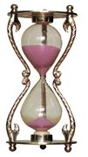
First, contact Kelley Medical…
…approve our repair estimate and issue a P.O…
…and receive a quality repair for a fraction of the manufacturer’s cost!
1.
2.
3.
4.
…wait 24 – 72 hours…

…and your satisfaction is guaranteed!

Advanced Data Management
Detailed and accurate documentation is a key component of administering your healthcare facility, and consequently Kelley Medical is proud to have developed one of the most sophisticated order-tracking and reporting systems in the industry. You will receive a detailed service report with every item returned to your facility. This document will provide specific information about each repaired component, as well as an overview of the general condition of your instruments. Any repairs that may need to be performed in the future will also be listed on this sheet. Every facet of your repair order is recorded in our database for speedy retrieval, should the need arise. We can easily furnish detailed repair histories in any format you require, reducing the need for you to keep intensive repair records. Our repair data can also be smoothly exported to any standard Microsoft Office application (i.e., Word, Excel), and many common database formats (i.e., Lotus, dBase).

Minimizing Repair Expenses
Maintaining and implementing cost-effective repair solutions is our top priority. To this end, we have developed an array of workshops and seminars for the education of our clients and the prevention of avoidable damage to equipment. These programs can be scheduled on-site, at your convenience, and we are happy to customize any of our training programs to suit your individual needs. Our approach teaches proper instrument handling techniques coupled with basic preventative maintenance, and the results speak for themselves. Facilities that take advantage of Kelley Medical inservice programs have fewer handling-related damage issues and may enjoy an overall reduction in repair expenses. Kelley Medical is also associated with many local healthcare professional organizations. Our involvement in this community helps us to stay abreast of the constantly changing medical landscape as well as keeping us in close touch with our current and future clients. Some of our relations are listed below:

- Indiana Biomedical Society
- Association of Perioperative Registered Nurses (AORN)
- IU School of Medicine, Division of Continuing Medical Education

Indiana Hospital Purchasing/Materials Mgmt. Association
- Certified Surgical Technologist Association
- Indiana Federation of Ambulatory Surgery Centers (IFASC)

Your Future With Kelley Medical
Carefully managed expansion is always on the horizon for Kelley Medical. We are constantly building new relationships and improving our repair services to include new and different instruments. Continuing education, for our clients as well as our personnel, is also a top priority. We have consistently taken advantage of improvements in materials and technology, cutting client repair costs and increasing repair quality. We pride ourselves on our same-day response, quality of workmanship and materials, and our prompt and truly efficient repair service. As a local facility, we hold some inherent advantages over out-of-state operations; convenience, accessibility, and ease of communication are three strengths that no remotely-located business can hope to match. Beyond these, however, is the simple fact that we know our customers, often on a personal level, and as a result we maintain a level of service that is measurably superior to that of our competitors. Our commitment to quality shines through in every aspect of our business, and our customers recognize this. Thank you for your interest and we look forward to working with you soon.
Kelley Medical, LLC
The Clear Choice for Instrument Repair Services

Call Today for Pricing and Additional Information
1-800-949-4225

References
Listed below are a few of our longest-standing valued customers. Please feel free to call any or all of these individuals for a firsthand review of the Kelley Medical experience.

- Galinton Bryan – (317) 871-7308
  - Administrator, Northside Gastroenterology Center
- Jim Hansen – (317) 841-8005
  - Administrator, Surgery Center Plus
- Lisa Thomas, RN – (765) 298-2900
  - Director of Surgical Services, Community Hosp. Anderson
- Charlene Foreman, RN – (765) 453-8441
  - OR Supervisor, Howard Community Hospital
- Betty Wright, RN – (317) 582-7450
  - OR Supervisor, Carmel St. Vincent Hospital
- Linda Trubey – (260) 920-2645
  - Central Supply Supervisor, Dekalb Memorial Hospital
- Jerry Keymon, CBET – (317) 274-0947
  - Clinical Engineering, IU Medical Center
- Jon Colip, CBET – (317) 582-7890
  - Clinical Engineering, Carmel St. Vincent Hospital
Pneumatic Instrument Repair

Repair Capabilities

Kelley Medical has been servicing area hospitals for over 15 years, giving us the experience you need to keep your instruments in excellent condition. Our pneumatic equipment repair technicians are trained to perform repairs on all makes and models of pneumatic instruments. We perform repair work at our own facility, giving our customers the lowest prices and the fastest instrument returns. We use only the highest quality parts and most skilled technicians, and our repair department manager has over 10 years of experience repairing a vast array of different makes and models of pneumatic equipment. Our capabilities include repairs on a variety of instruments, including autopsy saws and cast cutters. We service equipment from the following manufacturers:

- Zimmer/Hall
- Micro-Aire

- Anspach
- Stryker

- Howmedica
- Midas Rex

- 3M
- Synthes

Kelley Medical has loaner equipment available for many models; however, our 48 hour turnaround time eliminates the need for loaners in most circumstances. In the event of an emergency, rush repairs can be completed in just 24 hours.
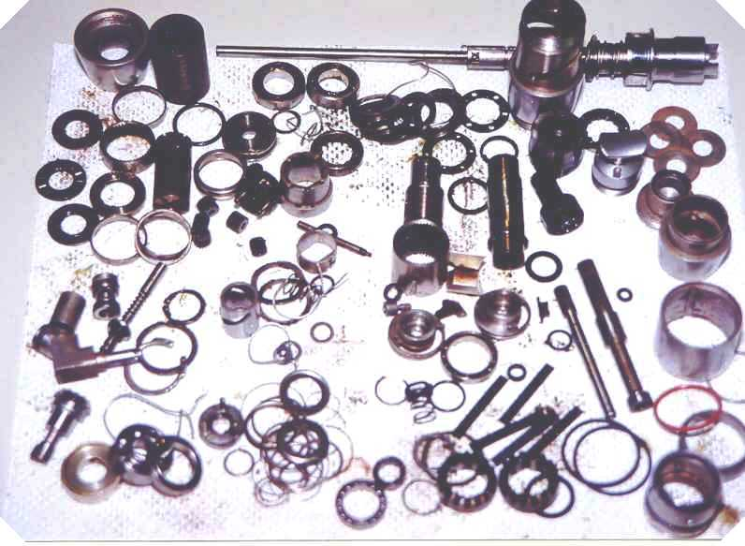
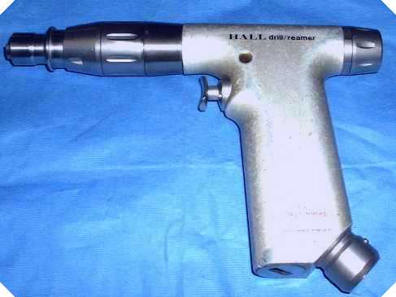
Hall Drill Reamer, Disassembled
Hall Drill Reamer, Assembled

Do you know what is inside of your handpiece?

Give Kelley Medical a chance to save your facility time and money through expedient and competitively-priced repair work. Take the KMI challenge: Call us with a description of the work done on a recently repaired pneumatic handpiece or hose, don't tell us what you paid, and we'll give you our price on the same repair. We guarantee that we will match or beat our competitors' lowest advertised prices while still providing the absolute best service in the industry. At Kelley Medical, we pride ourselves on workmanship of the highest caliber, and we refuse to compromise regardless of price.
Call Today!
1-800-949-4225
Pneumatic Instrument Repair

Repair Options

Level I - Minor Adjustments and External Repair
- System evaluation and testing
- Minor adjustments as required
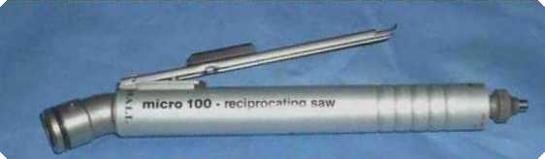
-Remove stuck burrs
-Adjust collet mechanism
-Adjust trigger mechanism
- Minor repairs as required
-Repair burr guard
-Replace pins
-Repair bent coupler
-Repair trigger mechanism
-Replace external O-rings and O-ring adapter

Level II - Complete Overhaul
- Includes repairs listed above, plus:
- Heavy ultrasonic cleaning and lubrication of all internal parts
- All tolerances reset to manufacturer's specifications
- Replacement of the following worn or missing parts:
-Seals and O-rings
-Bearings
-Springs
-Rotor vanes
-Roll pins
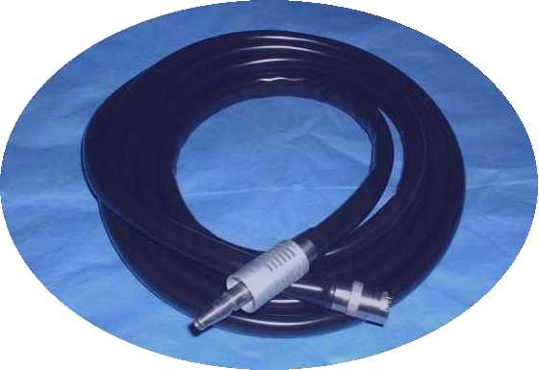
Level III - Full Refurbish/Quoted Repairs
- Pneumatic Instruments
-Discontinued models
-Custom-machined parts
-Housing or air inlet port damage
- Hoses
-Special length hoses
-Coupler replacement

Hose Repairs - Complete Overhaul
- Replace inner and outer sheath
- Rebuild check-valve assembly
- Realign coupler

Kelley Medical, LLC
The Clear Choice for Pneumatic Instrument Repair Services
Call Today for Pricing and Additional Information
1-800-949-4225

